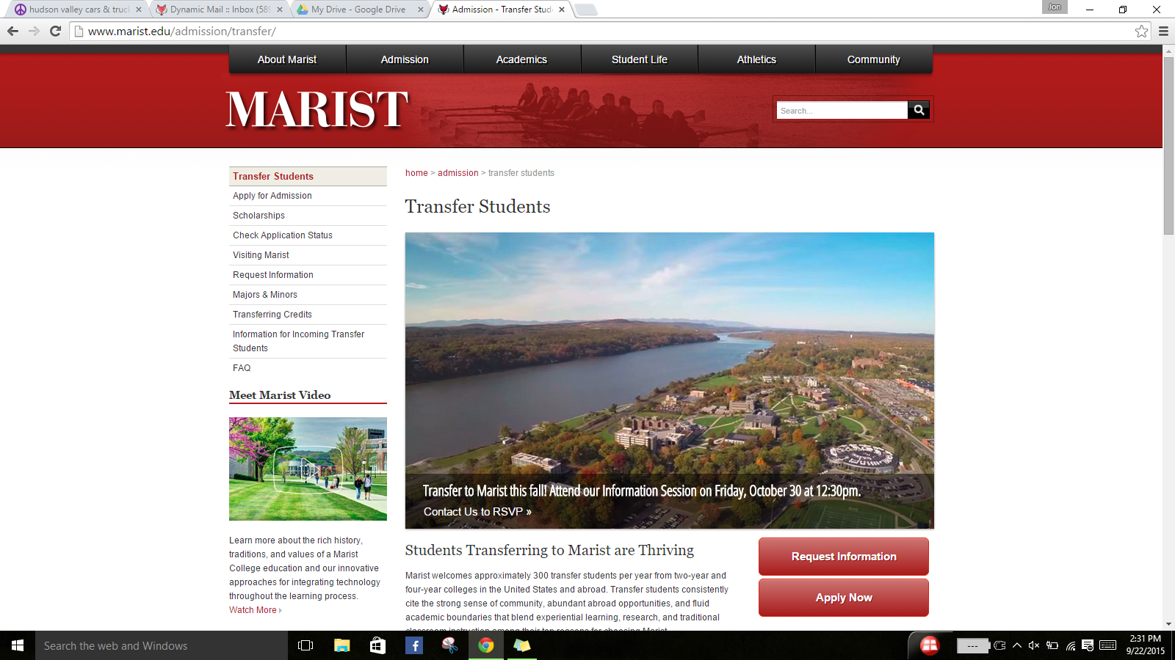

**Submit**

**Admin Edit Course:**

College/University:

Subject:

Course**:**

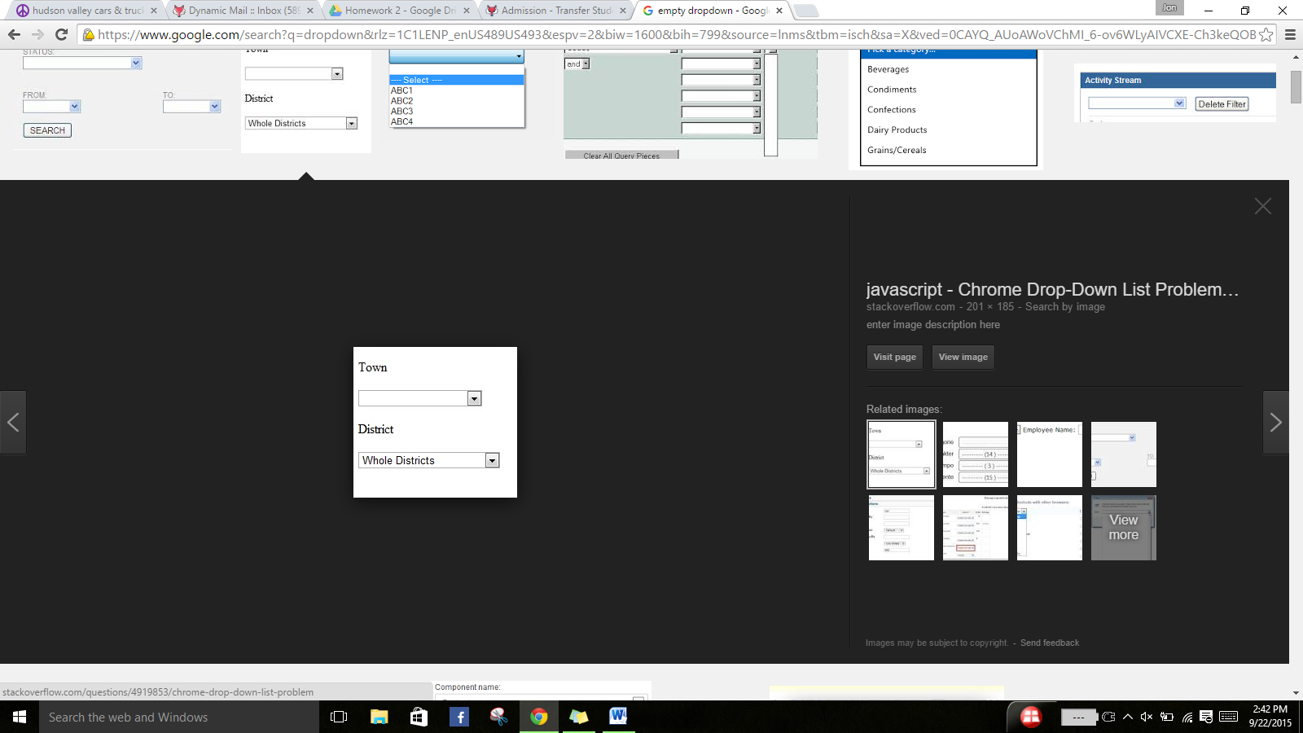

Dutchess Community…

Business

ACC_201

**Select**

**Course lookup**

**Edit:**

Course Name:

Course Number:

Credit Hours:

Subject:

Marist Equivalent:

Managerial Accounting

ACC_201

4

Business



ACCT_204N

**Save**

